***Retail Management System***

1. **Objectives:**

Our main objective is to keep record of all the processing starting from customer’s order till customer’s transaction. In between we keep track on customer’s order details from which staff member manages that particular order and customer transaction history and archive details.

* 1. Customers
  2. Orders
  3. Category
  4. Staff
  5. Transaction
  6. Delivery Details
  7. Archive

1. **Entities:**
   1. **Customers:**

It keeps all the customer details and records such as customer’s id, customer’s name, customer’s age, customer’s contact, customer’s email and gender.

* 1. **Orders:**

It keeps all customer’s order details such as order’s id, order’s name, order’s date etc.

* 1. **Staff:**

It keeps all record related to staff such as staff’s id, staff’s designation, staff’s name, staff’s age etc. This entity is link with order’s entity so that it regulates the process of customer’s order.

* 1. **Transaction:**

It keeps the record of customer’s transactions.

1. **Relations:**
2. **Customers:**

Customers __________Orders

1. **Orders:**

Orders __________ Customers

Orders __________ Category

Orders __________ Transaction

1. **Staff:**

Staff __________ Orders

Staff __________ Delivery Details

1. **Transaction:**

Transaction _________ Orders

1. **Attributes:**

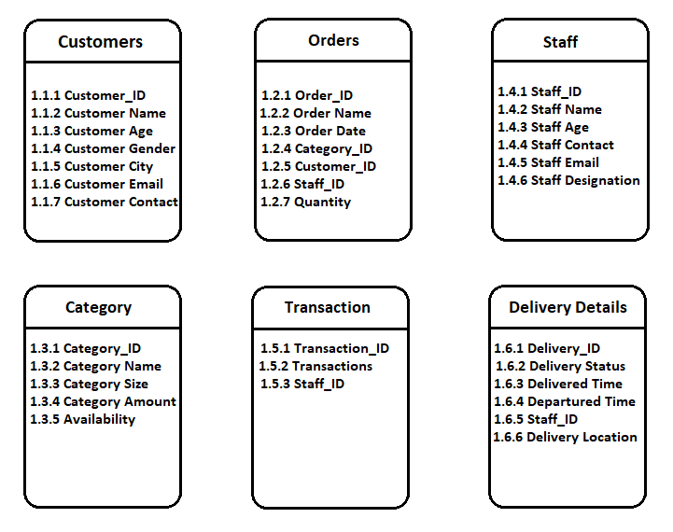

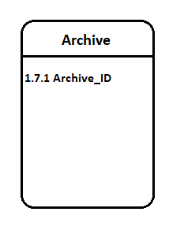

1. **Entity Relationship Diagram (ERD):**

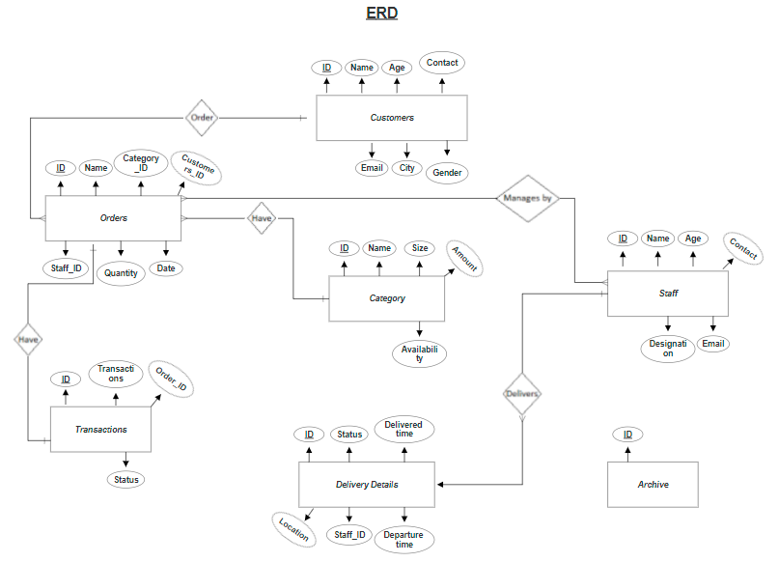

***RMS QUERIES***

--CREATE SCHEMA RMS --creating schema

--CREATE TABLE RMS.Customers -- creating customer table

--(

-- Customer_ID INT PRIMARY KEY IDENTITY(1,1),

-- Name VARCHAR(50),

-- Age VARCHAR(2),

-- Gender VARCHAR(50),

-- City VARCHAR(50),

-- Email VARCHAR(50),

-- Contact VARCHAR(50)

-- )

-- INSERT INTO RMS.Customers -- insert data into customer table

-- (

-- Name,

-- Age,

-- Gender,

-- City,

-- Email,

-- Contact

--)

--VALUES

--(

-- 'Ayesha Aslam',

-- 23,

-- 'Female',

-- 'Lahore',

-- 'ayeshaaslam986@gmail.com',

-- '0321956781'

-- )

--CREATE TABLE RMS.Staff -- creating staff table

--(

-- Staff_ID INT PRIMARY KEY IDENTITY(1,1),

-- Name VARCHAR(50),

-- Age INT,

-- Contact VARCHAR(50),

-- Email VARCHAR(50),

-- Designation VARCHAR(50)

-- )

-- INSERT INTO RMS.Staff -- insert data into staff table

-- (

-- Name,

-- Age,

-- Contact,

-- Email,

-- Designation

--)

--VALUES

--(

-- 'Ahmed',

-- 21,

-- '0322-844707-8',

-- 'ahmed997@gmail.com',

-- 'Order Man'

--)

--CREATE TABLE RMS.Category -- creating category table

--(

-- Category_ID INT PRIMARY KEY IDENTITY(1,1),

-- Name VARCHAR(50),

-- Size VARCHAR(50),

-- Amount VARCHAR(50),

-- Availability VARCHAR(12)

-- )

-- INSERT INTO RMS.Category -- insert data into category table

-- (

-- Name,

-- Size,

-- Amount,

-- Availability

--)

--VALUES

--(

-- 'Shirts',

-- 'M',

-- 2000,

-- 'In Stock'

--)

----TRUNCATE Table RMS.CATEGORY;

--CREATE TABLE RMS.[Delivery Details] -- creating Delivery Details table

--(

-- Delivery_ID INT PRIMARY KEY IDENTITY(1,1),

-- Status BIT,

-- [Delivered Time] datetime,

-- Location VARCHAR(50),

-- [Departure Time] datetime,

-- Staff_ID INT UNIQUE FOREIGN KEY REFERENCES RMS.Staff(Staff_ID)

--)

-- INSERT INTO RMS.[Delivery Details] -- insert data into Delivery Details table

-- (

-- Status,

-- [Delivered Time],

-- Location,

-- [Departure Time],

-- Staff_ID

--)

--VALUES

--(

-- 0,

-- NULL,

-- 'Lahore',

-- NULL,

-- 1

--)

--CREATE TABLE RMS.Orders -- creating Orders table

--(

-- Order_ID INT PRIMARY KEY IDENTITY(1,1),

-- Name VARCHAR(50),

-- Date date,

-- Quantity VARCHAR(1),

-- Staff_ID INT FOREIGN KEY REFERENCES RMS.Staff(Staff_ID),

-- Customer_ID INT UNIQUE FOREIGN KEY REFERENCES RMS.Customers(Customer_ID),

-- Category_ID INT UNIQUE FOREIGN KEY REFERENCES RMS.Category(Category_ID)

--)

-- INSERT INTO RMS.Orders -- insert data into Order table

-- (

-- Name,

-- Date,

-- Quantity,

-- Staff_ID,

-- Customer_ID,

-- Category_ID

--)

--VALUES

--(

-- 'Lhr9262021',

-- '9/26/2021',

-- 3,

-- 2,

-- 1004,

-- 70

--)

--CREATE TABLE RMS.Transactions -- creating Transactions table

--(

-- Transactions_ID INT PRIMARY KEY IDENTITY(1,1),

-- Transactions_Amount decimal(18, 2),

-- Status BIT,

-- Order_ID INT UNIQUE FOREIGN KEY REFERENCES RMS.Orders(Order_ID)

--)

-- INSERT INTO RMS.Transactions -- insert data into Transactions table

-- (

-- Transactions_Amount,

-- Status,

-- Order_ID

--)

--VALUES

--(

-- 0,

-- 0,

-- 1

--)

--CREATE SCHEMA RMSA --creating schema

--CREATE TABLE RMSA.Archive -- creating Archive table

--(

-- Archive_ID INT PRIMARY KEY IDENTITY(1,1)

--)

-------------------------------------------------------------

-- INSERT INTO RMS.Customers -- insert data into customer table

-- (

-- Name,

-- Age,

-- Gender,

-- City,

-- Email,

-- Contact

--)

--SELECT TOP 68 * FROM MOCK_DATA

-------------------------------------------------------------

-- INSERT INTO RMS.Staff -- insert data into staff table

-- (

-- Name,

-- Age,

-- Contact,

-- Email,

-- Designation

--)

--SELECT TOP 998 * FROM MOCK_DATA;

-------------------------------------------------------------

-- INSERT INTO RMS.Category -- insert data into category table

-- (

-- Name,

-- Size,

-- Amount,

-- Availability

--)

--SELECT TOP 999 * FROM MOCK_DATA;

-------------------------------------------------------------

--INSERT INTO RMS.[Delivery Details] -- insert data into Delivery Details table

-- (

--Status,

--[Departure Time],

--[Delivered Time],

--Location,

--Staff_ID

-- )

--SELECT

--1 AS [Status],

--getutcdate() AS [Departure Time],

--getutcdate()+2 AS [Delivered Time],

--RMS.Customers.City,RMS.Orders.Staff_ID

--FROM

--(

-- RMS.Customers

-- INNER JOIN RMS.Orders ON RMS.Customers.Customer_ID = RMS.Orders.Customer_ID

-- INNER JOIN RMS.Transactions ON RMS.Orders.Order_ID = RMS.Transactions.Order_ID

--)

--SELECT * FROM MOCK_DATA

--WHERE Staff_ID != 1;

-------------------------------------------------------------

--DROP TABLE RMS.Category;

--ALTER TABLE RMS.Orders

--ADD Category_ID INT UNIQUE FOREIGN KEY REFERENCES RMS.Category(Category_ID);

--UPDATE RMS.Orders

--SET Category_ID = 1

--WHERE Order_ID = 1;

-------------------------------------------------------------

-- INSERT INTO RMS.Orders -- insert data into Order table

-- (

-- Name,

-- Date,

-- Staff_ID,

-- Quantity,

-- Customer_ID,

-- Category_ID

--)

--SELECT

-- MD.[Name],

-- MD.[Date],

-- RS.Staff_ID,

-- MD.Quantity,

-- MD.Customer_ID,

-- MD.Category_ID

--FROM

-- MOCK_DATA AS MD

-- INNER JOIN RMS.Staff AS RS ON MD.Staff_ID= RS.Staff_ID

--WHERE

-- Designation = 'Order Man';

-------------------------------------------------------------

--UPDATE RMS.Category

--SET

-- Amount = REPLACE(Amount,'$','')

-------------------------------------------------------------

--UPDATE

-- RMS.Transactions

--SET

-- Status = 1

--WHERE

-- Transactions_ID = 1;

-------------------------------------------------------------

--CREATE PROCEDURE Calc_Transactions -- SP of No Of Transactions

--AS

--SELECT

-- COUNT(*) AS [No Of Transactions]

--FROM RMS.Transactions

-------------------------------------------------------------

Alter PROCEDURE Move_Arc

AS

INSERT INTO RMSA.Archive

(

Status,

[Delivered Time],

Location,

[Departure Time],

Staff_ID

)

SELECT

Status,

[Delivered Time],

Location,

[Departure Time],

Staff_ID

FROM

RMS.[Delivery Details]

WHERE

Status = 1;

DELETE FROM

RMS.[Delivery Details]

WHERE

Status = 1;

--SELECT * FROM RMS.Orders;

--SELECT * FROM RMS.Category;

--SELECT * FROM RMS.Transactions;

--SELECT * FROM RMS.[Delivery Details];

--SELECT * FROM RMS.Customers;

--Select * from RMSA.Archive;

TRIGGERS

USE [RETAIL DB]

GO

/****** Object: Trigger [RMS].[OrderafterCRUD] Script Date: 9/25/2021 3:41:16 AM ******/

SET ANSI_NULLS ON

GO

SET QUOTED_IDENTIFIER ON

GO

ALTER TRIGGER [RMS].[OrderafterCRUD]

ON [RMS].[Orders]

AFTER INSERT,DELETE,UPDATE

AS

BEGIN

SET NOCOUNT ON;

INSERT INTO RMS.Transactions

(

Transactions_Amount,

Status,

Order_ID

)

SELECT

(SELECT

Category.Amount

FROM

inserted

INNER JOIN RMS.Category ON (inserted.Category_ID = Category.Category_ID)

WHERE

Category.Availability = 'In Stock'

) AS Transactions_Amount,

1 AS [Status],

Order_ID

FROM

inserted

INSERT INTO RMS.[Delivery Details]

(

Status,

[Departure Time],

[Delivered Time],

Location,

Staff_ID

)

SELECT

1 AS [Status],

getutcdate() AS [Departure Time],

getutcdate()+2 AS [Delivered Time],

RMS.Customers.City,RMS.Orders.Staff_ID

FROM

(

RMS.Customers

INNER JOIN RMS.Orders ON RMS.Customers.Customer_ID = RMS.Orders.Customer_ID

INNER JOIN RMS.Transactions ON RMS.Orders.Order_ID = RMS.Transactions.Order_ID

)

--------------------------------------------------------------------

END

